NEW MEMBER INSTRUCTIONS FOR WAMSS MEMBERSHIP
TO PAY WITH PAYPAL

If you need to pay by check STOP: print out the registration form as listed under the join us tab.  Select the join us tab and the membership application. | 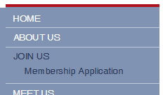

This will bring up the application. Complete all information to ensure you are connected correctly. 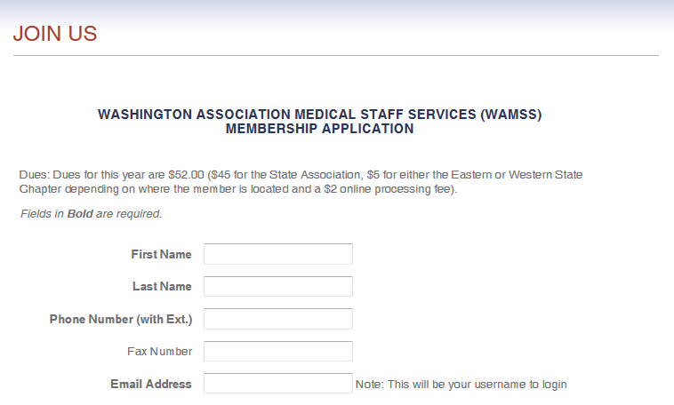

You can set your own password for continued access
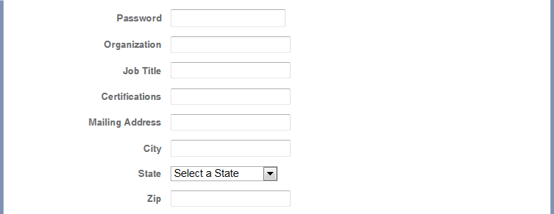

Select a membership category and a chapter membership. 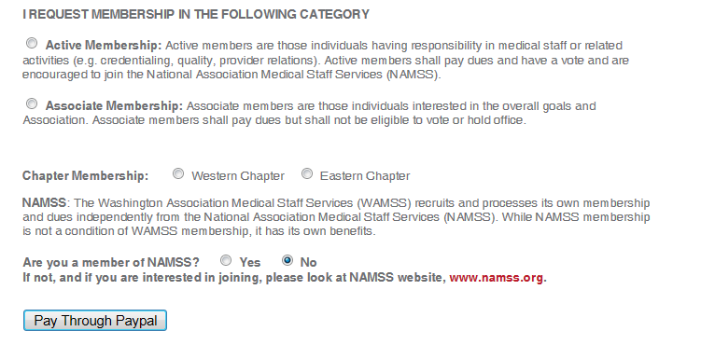
Press Pay Through Paypal option and it will automatically direct you to the paypal payment option. Select the pay with debit or credit card option.
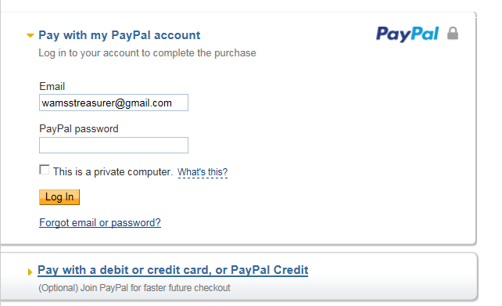
Make sure that you select the credit card option, complete the information.
