MEMBER INSTRUCTIONS FOR WAMSS MEMBERSHIP RENEWAL
TO PAY WITH PAYPAL

If you need to pay by check STOP: print out the registration form as listed under the join us tab.  Log into the members only section.  Select update member profile. | 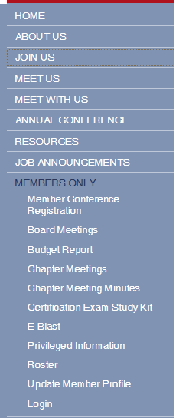

If you try to renew after the deadline this will appear and will direct you to pay via paypal without updating any information. See those instructions further down.
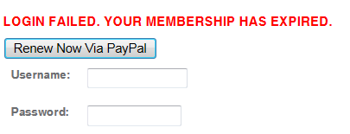

Please review your profile and ensure all information is up to date. 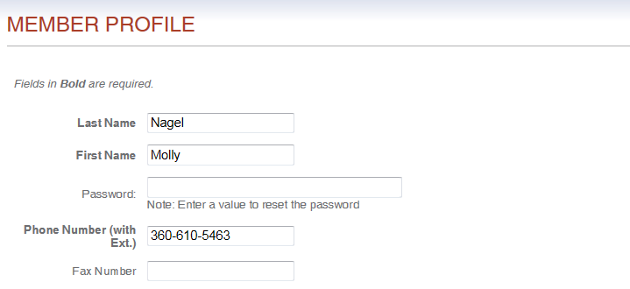
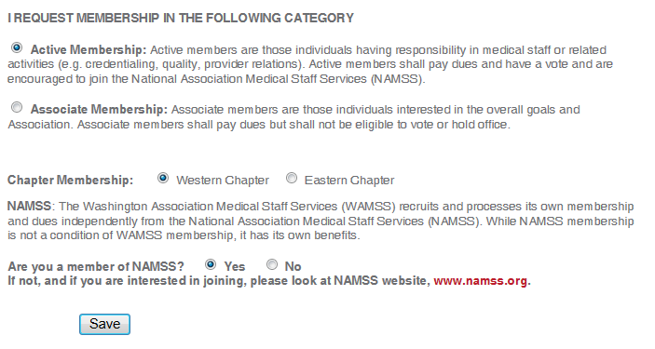

By selecting submit, this will automatically direct you to the paypal payment option.
Select the pay with debit or credit card option.
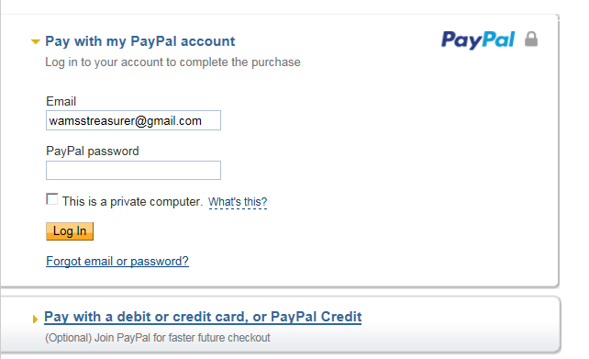
Make sure that you select the credit card option, complete the information.
