Procedure for Applying to NAMSS for CE credit for a Meeting

First go onto the NAMSS website. Login with your user name and password.
NAMSS will have to add you on the back end to the proper WAMSS account. This can be accomplished by contacting them, telling them who you are and getting them to hook you up. Ideally this should be accomplished by your predecessor before you take over your new role.
Then go to the Education Tab
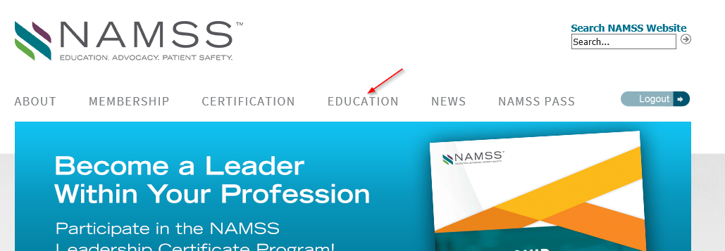

Since this is a WWAMSS Chapter meeting that has business + education, you will have to go to the CE Program Accreditation Application system. Click on the name:
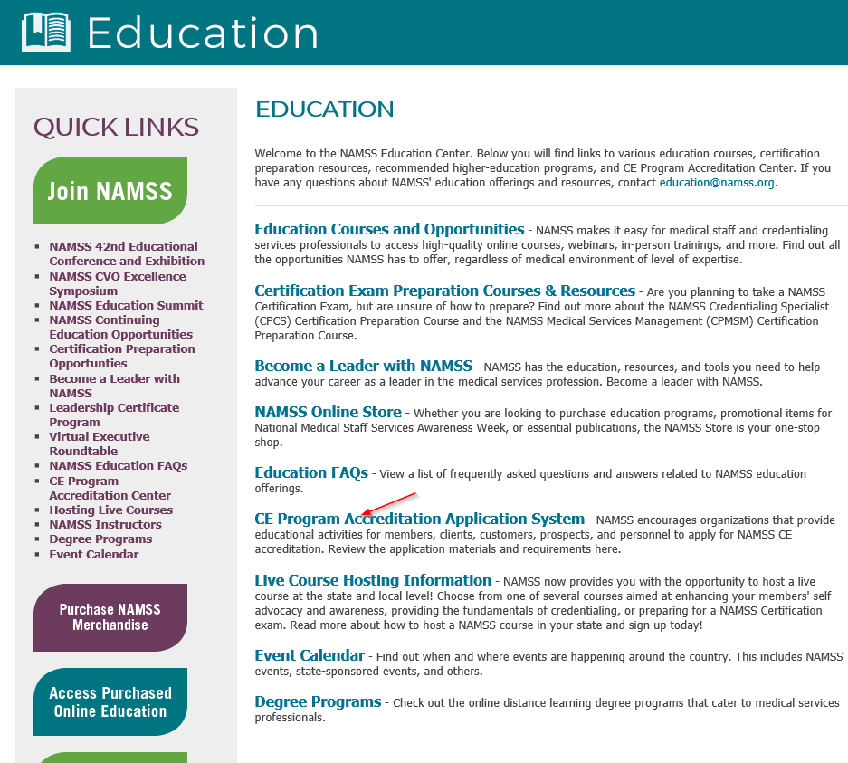
Here are the CE Program Accreditation Guidelines:
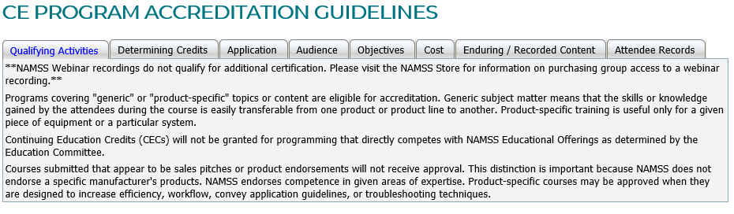
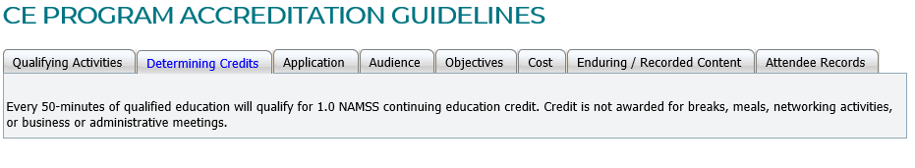
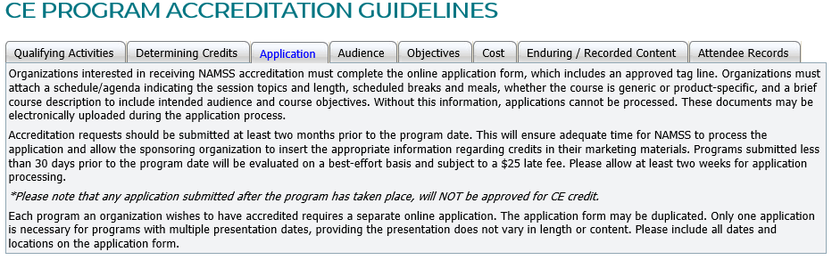
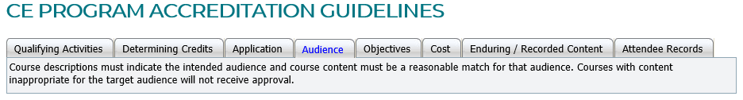
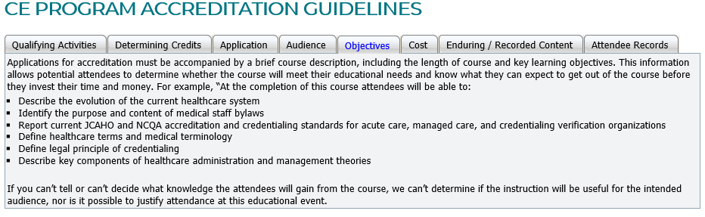
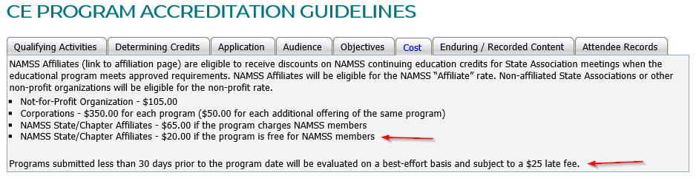

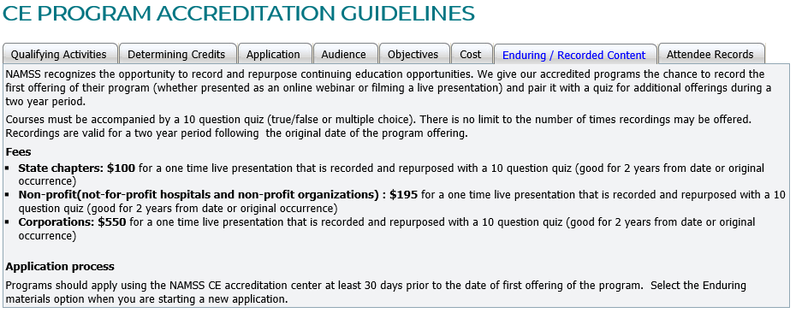
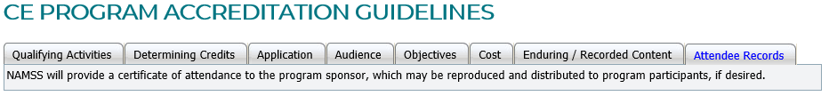
Once you are clear on the guidelines, you are almost ready to start the process.
Things you will need to have on hand:
- An agenda prepared for the chapter meeting where you will present the educational topic:
- Information from the presenter to include title of presentation, what will be discussed and the objectives.
- Credit card or debit card info to pay the $20.00 Fee.

***THIS IS A VERY IMPORTANT PIECE OF INFORMATION TO KNOW***** If your meeting meets the criteria of having a chapter business meeting along with education, you must use this system. So, if you wanted to present a NAMSS webinar, you would only have to pay the $20.00 for the CEU application and then the webinar fee. This is how you get around having to pay bunches of money for enough CE credits. If you use the Accreditation Center, you get one CE certificate and you can email it to like 50 people if you had that many. If you just buy the Webinar, NAMSS is assuming you are buying it only for you and/or a handful of coworkers, which is why they only give you a couple of CE certificates when you directly purchase the webinar and skip the Accreditation Center part. You can get the course name, info and objectives from the write up of the specific webinar you want on the Education Center page****

Here's an agenda I made up:

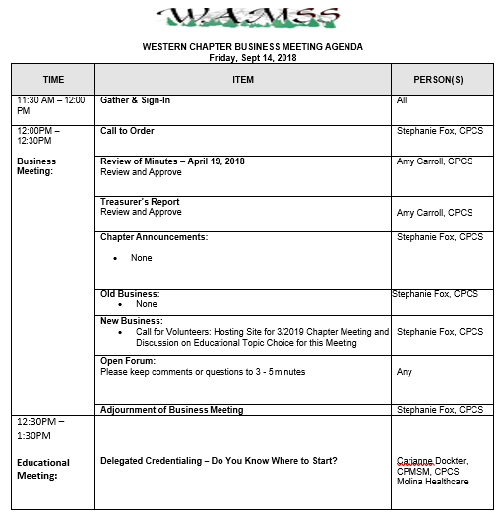
Here’s the info supplied to us on Carianne’s presentation:
Title: Delegated Credentialing – Do You Know Where to Start?
Description: My presentation will be focused on what Medical Staff offices need to do to prepare for Credentialing Delegation with Managed Care Organizations. We will go over NCQA standards that differ from Joint Commission, how and when state Medicaid and Medicare Advantage standards come into play, and some basic requirements for MCO needs (e.g. panel size, practitioners included in delegation, and reporting requirements).
Learning Objectives:
At the completion of this program, attendees will be able to:
1. Understand the differences between hospital and managed care credentialing
2. Understand the delegation oversight process
3. Understand what is needed to meet MCO credentialing/delegation requirements
Ok, time to go to the CE Accreditation Center:

Choose the proper organization:
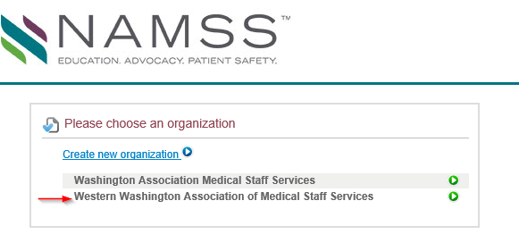
Click on Start a New Application:
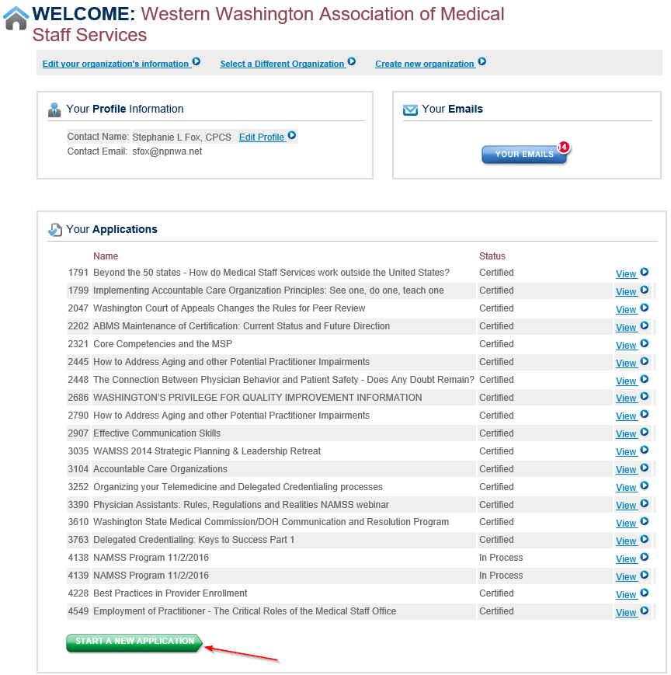

Click on the Application Type and Create:
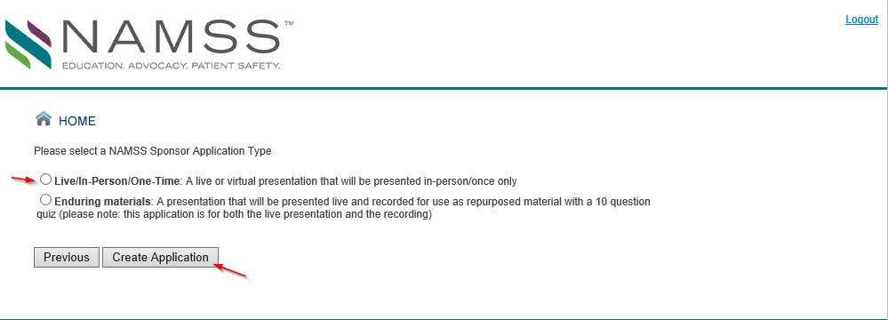

On the next screen, Click on Continue
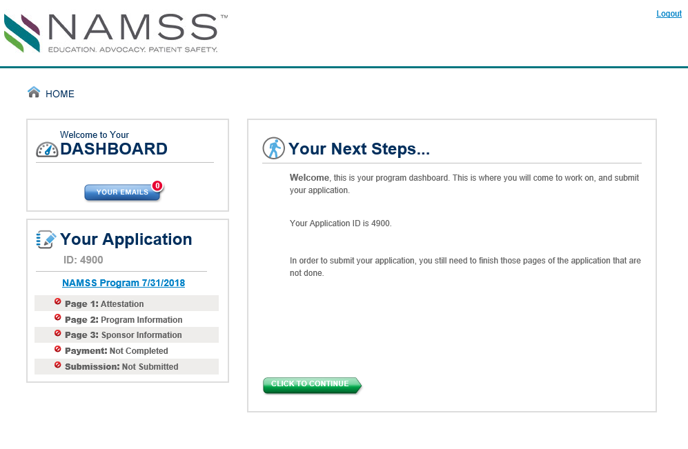
This will bring you to the next screen. Notice that as you complete each section, the red “No” sign on the left next to each step turns into a green check mark. Click on “I agree” and “Continue”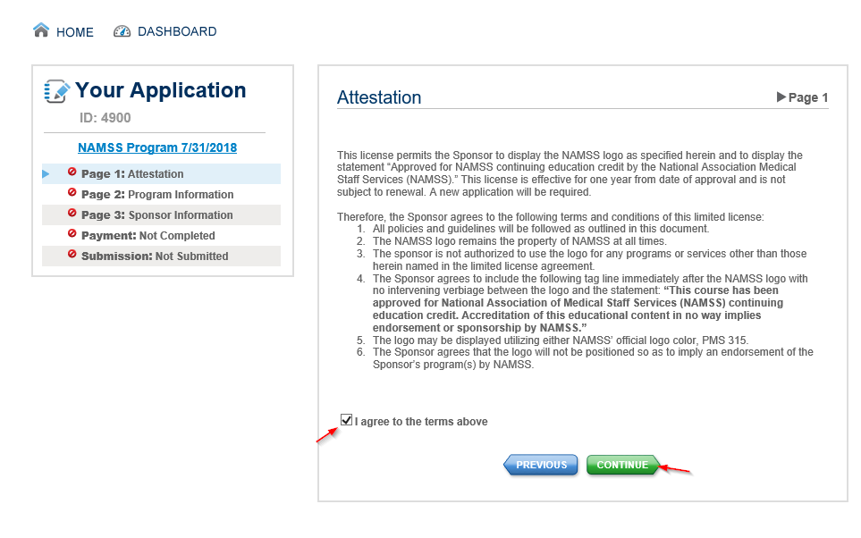

This will take you to the next page to start submitting your information about the meeting, agenda, and presentation.
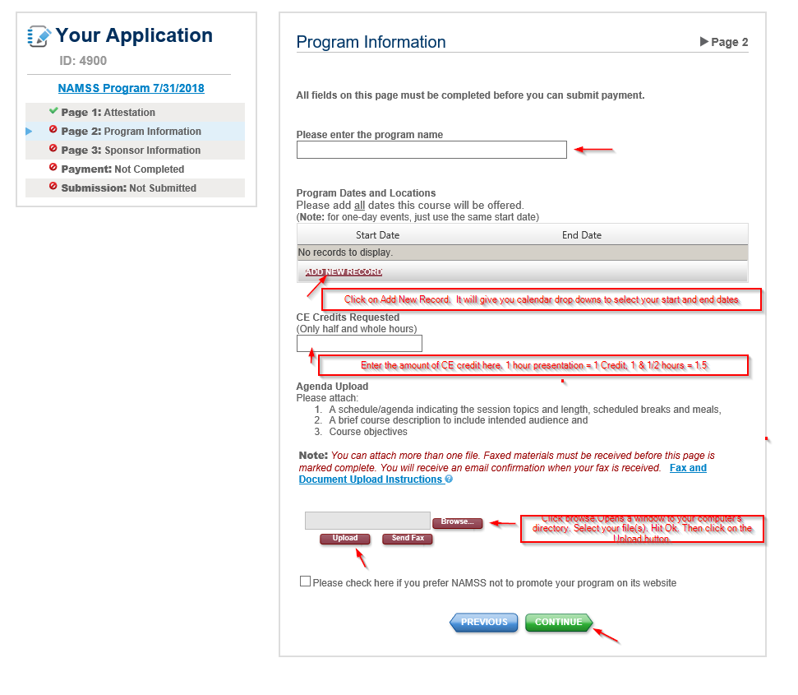
Once you click on Continue, it will take you to the Sponsor Information Screen.
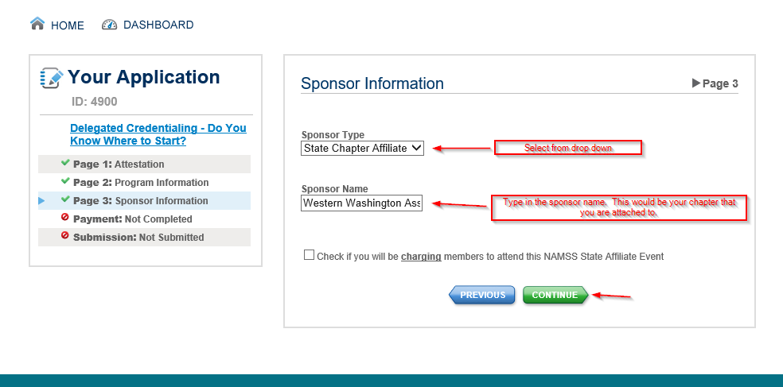
Once you click on Continue here, it will take you to the Payment Screen. Have your debit or credit card ready!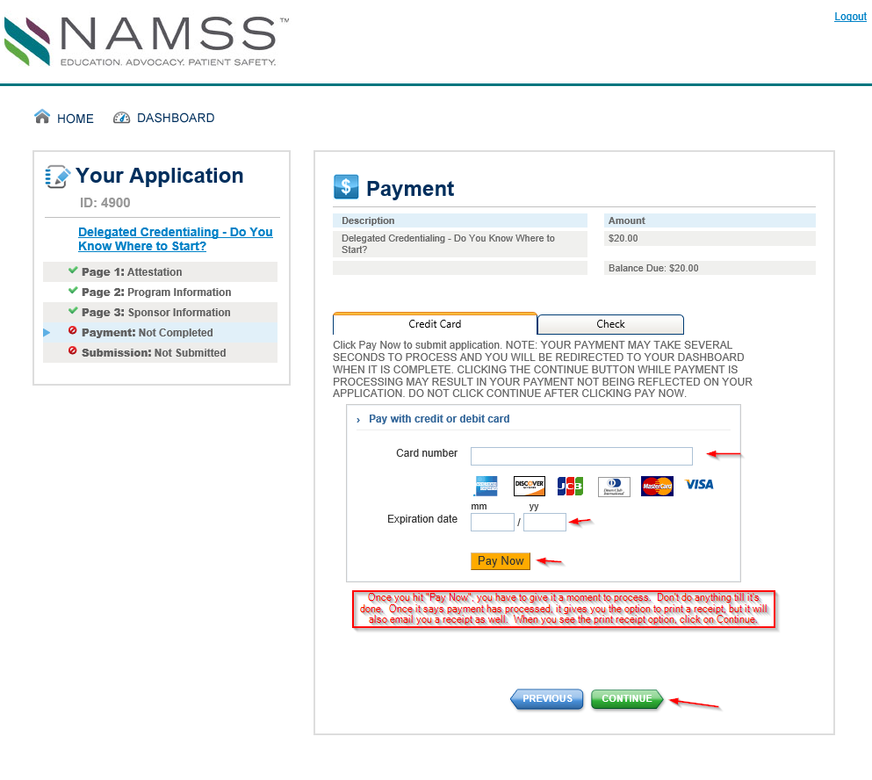
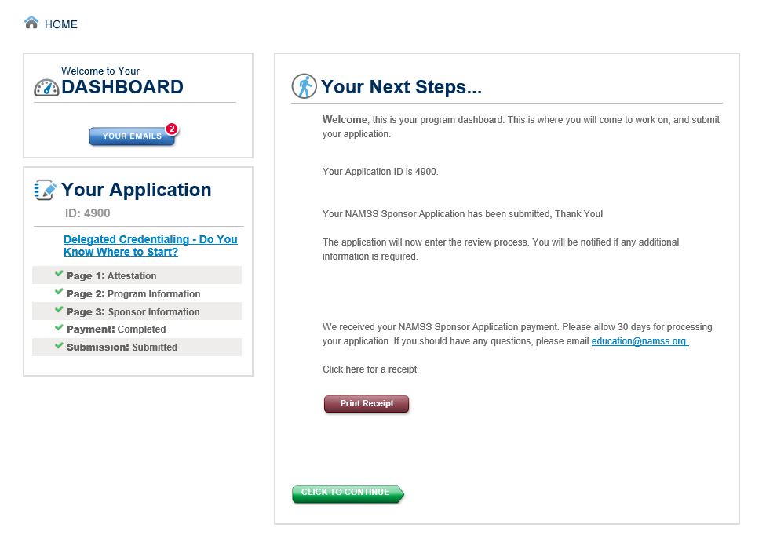
Now you have submitted it. You can go ahead and log out of NAMSS for now.

Next step: Assuming submission is done and your submission was approved. You are about to have your meeting. Now you need to go online and get the CE certificate for your meeting.
Log onto NAMSS.
Click on Education.
Click on CE Accreditation Center
Select your Organization.
It will pull you up to your association’s page.
Notice under “Your Applications”…it will have the title of a class, the status, and a button that says view.
Let’s pretend the first one on the list is the one we want. Click on the View Button for it.
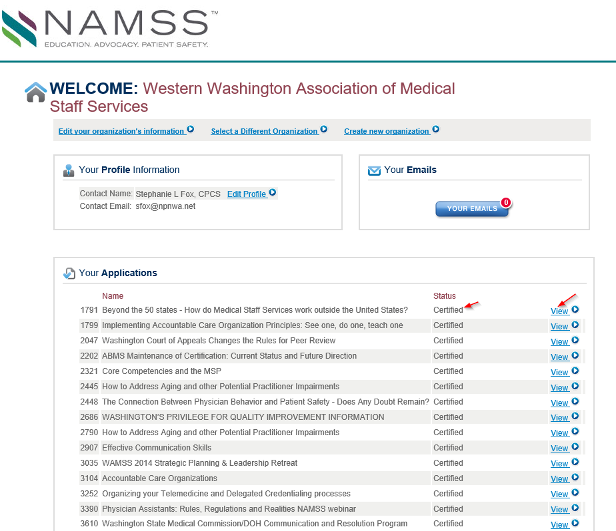
This is takes you to the screen where you will go to download your CE certificate that you can email out to all the members that will attend your meeting.

It will say: Click here to download for date (whatever the date of your meeting is).
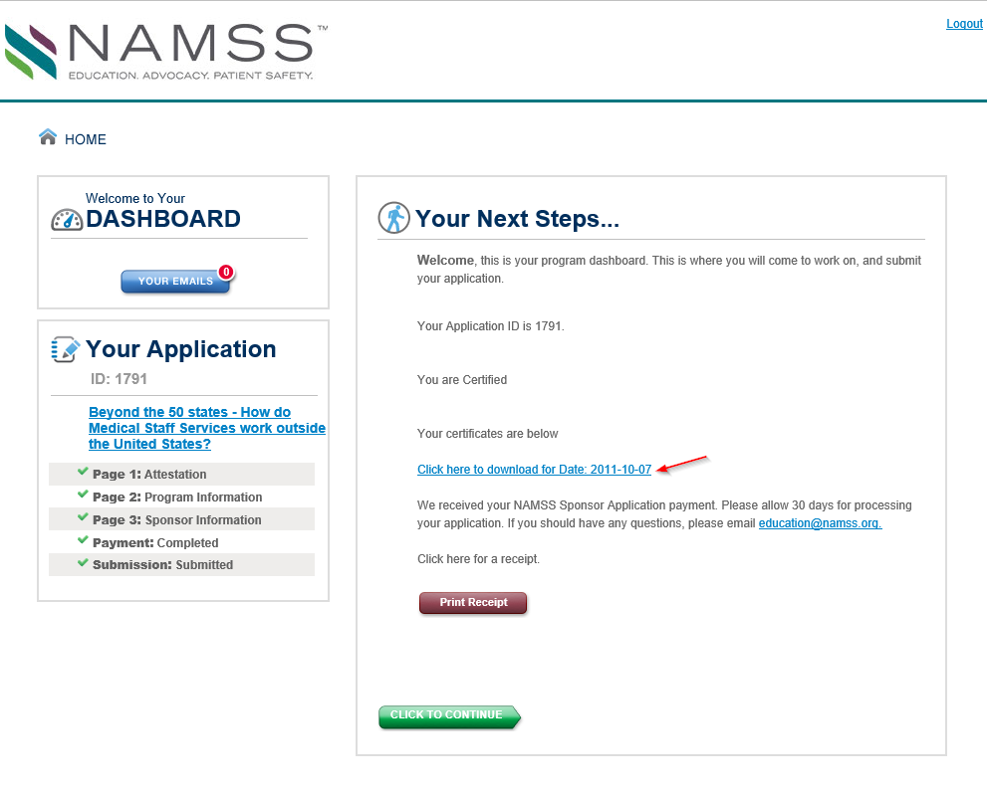
Once you click, you should get this pop up below. Click on Open.
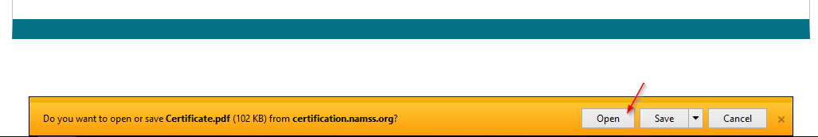
This will open up the PDF of the certificate. Give a look over, make sure all of the information is correct. Notify NAMSS if the certificate has incorrect information on it so that they can fix it and resend it to you. Then save a copy to your computer for distribution to members after the meeting is over. Please try to ensure that you do this within 7 days time after the meeting is done.

