How to Join a WebEx Meeting:
For a complete overview of getting started with Cisco Webex meetings, please see their helpful tutorial here: Get Started with Cisco Webex Meeting for Attendees
Some basic details about how to join a Webex meeting:
1. You’ll receive an email invite to the Webex meeting with instructions on how to join.
- Click the link to the meeting in the email.
- Once at the website, click the “Join meeting” button to connect.

2. Connect Your Audio/Video: once you click the “Join meeting” button, you’ll get an audio and video dialog box.
- To connect to audio, you can use your phone, computer or a video device.
  - Phone: You can dial in using the phone number in the email invite.
  - Computer: When joining a meeting, the audio and video connection dialog box will appear to connect your speaker/mic/camera. Please ensure your computer has these devices plugged in if using.
- Confirm your details on the connection dialog box, then click the “Connect Audio and Video” Button. Example dialog box below.
- Please either Dial in or use Audio and Video to join the meeting. DO NOT USE BOTH

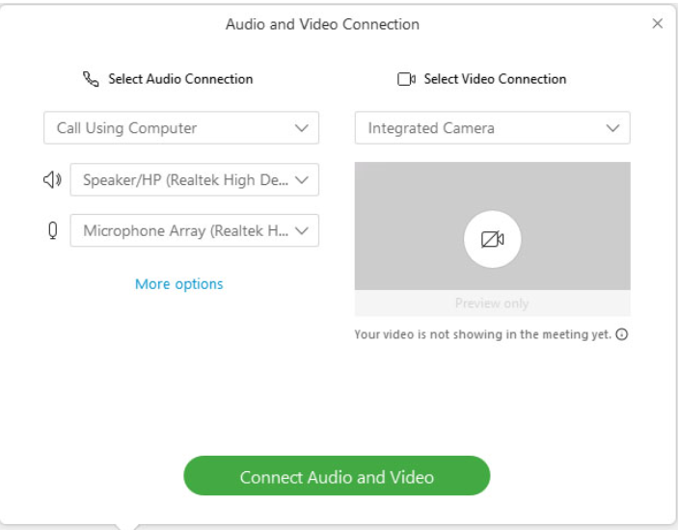
3. Now you should be connected to the meeting!
4. To share your screen/content, Click the “Share Content” button:  and choose what you’d like to share with the group from the options listed. You should be able to share your screen or individual programs, for example excel, for everyone to see.
- If sharing a webinar, the best option would be to choose the specific program the webinar is playing on.
- Let everyone know to please mute to decrease background noise.

5. How to end the meeting: click File and select “End Meeting” or click  red X Circle button on screen, this will end your meeting session.

For more detailed information and troubleshooting, please see the WebEx Help Center Website.
*Information outlined above is taken directly from the WebEx Webiste.

