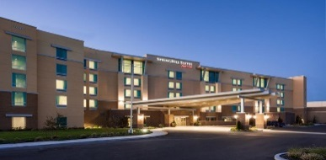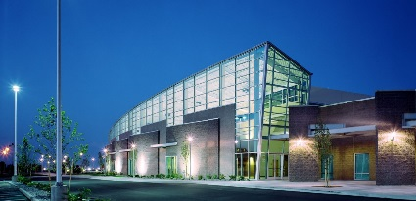
Washington Association Medical Staff Services

2019 Education Conference Registration
"Together Towards the next 40 years”

Wednesday, April 24 – Friday, April 26, 2019
SpringHill Suites, Kennewick Tri-Cities
Please check
Tuesday CPMSM/CPCS Study Group - WAMSS Member_{(4/23,} _{includes} _{lunch)} | $75
Tuesday CPMSM/CPCS Study Group - Non-Member _{(4/23,} _{includes} _{lunch)} | $100
Tuesday Credentialing 101 Course - WAMSS Member _{(4/23,} _{includes} _{lunch)} | $75
Tuesday Credentialing 101 Course - Non-Member _{(4/23,} _{includes} _{lunch)} | $100
Full Conference - WAMSS Member | $425
Full Conference - Non-WAMSS Member | $500
*New* Full Conference Group Rate Special (Buy 4 Full Conference Registrations and Get One Free! – WAMSS Members Only (Snail mail 5 registration forms together with check – online option not available) | $1700
One Day WAMSS Member - Wed or Thurs or Fri (please circle and/or select online option) | $200
One Day Non-WAMSS Member - Wed or Thurs or Fri (please circle and/or select online option) | $250
Two Day WAMSS Member – Wed/Thurs or Thurs/Fri (please circle and/or select online option) | $300
Two Day Non-WAMSS Member – Wed/Thurs or Thurs/Fri (please circle and/or select online option) | $350
Wednesday Night Social Dinner Guest Ticket (Free for Members) | $40
WAMSS Membership Dues* | $50
Total Enclosed:
Special Meal Request: Vegetarian Vegan Gluten Free

**Join or Renew your WAMSS Membership with the conference registration and you can use the member registration price.
Attending Wednesday Night Social?: (Check here)

Name: Title:

Organization: E-Mail:

Address: City: State: Zip:

Phone: Fax: Certified: CPCS CPMSM
WAMSS Member: Yes No First Time Attendee: Yes No
Make checks payable to: WAMSS Registration Deadline: March 30, 2019
Conference materials will be available at www.wamss.org
WAMSS Conference Registration
C/O Molina Healthcare, INC
PO Box 4004
Bothell, WA 98041-4004
Attn: Carrianne Dockter, Ste. 100

Return completed registration form to:

General Conference Information 2019

Who Should Attend:

- Medical Staff Services Professionals (MSP’s)
- Provider Credentialing Specialists
- Centralized Verification Organization Professionals
- Health Plan/Managed Care Professionals
- Clinic/Group Practice Credentialing Professionals
- Provider Enrollment Credentialing Specialists
- Accreditation/Compliance Professionals
- Quality & HR Professionals Cross Training
- Physician Executives

Hotel Accommodations, Directions and Map

Book Room at: Book your group rate for WA Assn of Medical Staff Services

SpringHill Suites Kennewick Tri-Cities
7048 West Grandridge Boulevard, Kennewick, WA 99336

Hotel Rates: $129.00

- A block of guest rooms has been reserved for WAMSS. Please remember to mention “WAMSS” when making reservations. Room rates will be guaranteed until March 22, 2019. Hotel cancellation policy is 24 hours prior to our 4:00p.m. check in time to avoid a cancellation charge.

- Dress Attire during the conference is business casual. Please remember to dress in layers during meetings due to fluctuation in room temperatures. Jeans are welcome on Friday for travel home.

- Perfume Policy To ensure everyone’s comfort, please keep the use of perfume/cologne to a minimum.

- Cell Phones/Pagers/Computers As a matter of courtesy to other attendees please set all computers, cell phones, pagers and other mobile devices to silent or vibrate mode. If you need to take a call, please leave the session to do so.

- Continuing Education Credits Application has been made to the National Association Medical Staff Services for continuing education hours. Continuing Education credits will be emailed to attendees by May 1, 2019.

- Registration Deadline and Conference Cancellation/Change Policy
The deadline for conference registration is March 30, 2019.
Full refund, if cancellation is requested in writing by March 29, 2019. After March 30, 2019 – A $75 cancellation fee will be charged.
After April 9, 2019 – No refunds, but you may substitute another person
Contact: Carrianne Dockter, CPCS, CPMSM - Carrianne.Dockter@MolinaHealthcare.com

Conference Dining  Tuesday April 23  Welcome Reception  With Appetizers | Wednesday April 24  Breakfast Morning snack Lunch on own Afternoon snack  Social Night Activity with Dinner | Thursday April 25  Breakfast  Lunch with Annual Meeting Afternoon snack  Dinner on own | Friday April 26
 |  |  | Breakfast
 |  |  | Morning snack

