Who We Are  The Washington Association Medical Staff Services (WAMSS), an affiliate of the National Association Medical Staff Services (NAMSS), was founded in 1979 by enthusiastic medical staff professionals throughout the state of Washington.  From a handful of members, WAMSS now includes representatives from hospitals, physician groups, and healthcare insurance plans across the state. These organizations benefit by having Medical Staff Professionals who are up-to-date in the aspects of medical staff management. WAMSS continues to promote the goals and objectives of our founding members by meeting regularly as chapters and collectively at an annual education meeting. |  |  | Vision  Continually improve the quality and safety of patient care through medical staff professionals and related fields within Washington State.  Mission  To promote education and collaboration by uniting persons who are engaged in medical staff, provider credentialing and enrollment, privileging, accreditation and regulatory compliance, and other diverse healthcare activities in Washington State.  Contact Us  Shannon Rochon, CPCS  President 2019-2020  Nominating Committee Chair  Email: president@wamss.org  Lynn Everts, CPCS  President-Elect 2019-2020  Membership Chair  Email: membership@wamss.org  WAMSS Website:  www.wamss.org |  |  | - Washington Association Medical Staff Services

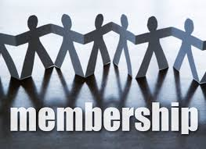  Why should you be a member of WAMSS?  - Join a professional credentialing organization whose members credential and privilege licensed independent practitioners following AAAHC, CMS, DNV, Joint Commission, NCQA, URAC guidelines  - Connect with other Medical Staff Professionals who do the same work you do  - Stay up to date on regulatory and legislative changes  - Share resources with colleagues. Have a question(s)? E-Blast it out to the membership for clarification, help and/or problem solving  - Access to Mentors and Study Groups to help obtain your NAMSS CPCS and/or CPMSM certifications  - Leadership development by serving as a WAMSS Leader Volunteer  - Scholarship and Award Programs  - Attend networking opportunities and educational programs at our annual conference for professional development  - Access to resources on WAMSS.org website |  |  | 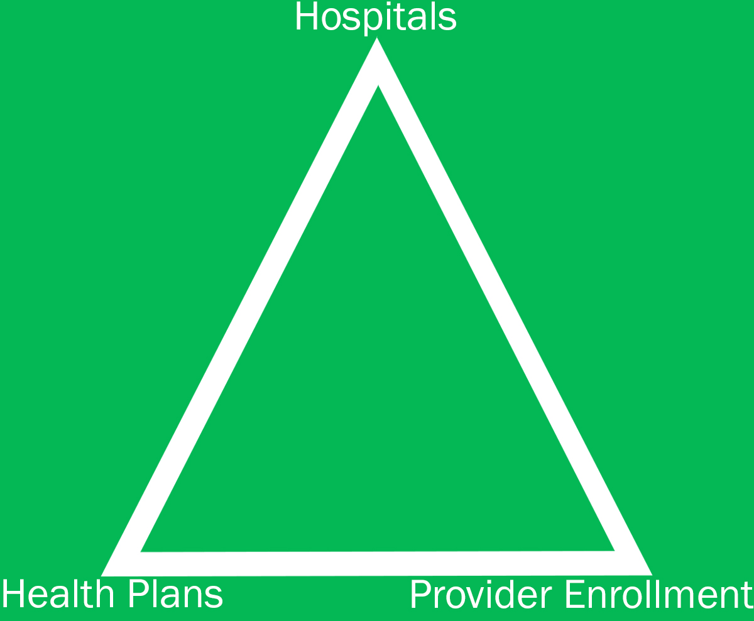  “No one party can exist without the other”  What are WAMSS Values:  Education  Supporting continuous learning of individual members to enhance their organizations and WAMSS.  Collaboration  Working together individually and through WAMSS communication tools to develop an engaged and valued workforce for our institutions.  Leadership  Providing opportunities to develop each member’s leadership potential through development and leadership opportunities within the organization.  WAMSS values all facets of our industry  . |  |  | Why the Credentialing Process?  “To ensure that patients receive  the best care possible”  What is the credentialing process?  The credentialing process and the granting of privileges and membership authorizes the practitioner to perform certain clinical functions for which they are determined to be qualified and competent.  The standard credentialing process begins with the review of the submitted application for completeness. This process also includes primary source verification (PSV).  Examples:  - State License & Federal DEA  - Liability Insurance  - Medical Education  - Board Certification(s)  - Work History  - Hospital Privileges  - Peer References  - National Practitioner Data Bank (NPDB)  - Medicare Opt-out  - Office of Inspector General (OIG)  - Criminal background checks

