How to Schedule / Host a meeting
For a complete overview of getting started with Cisco Webex meetings, please see their helpful tutorial here: Get Started with Cisco Webex Meeting for Hosts.
Weblink: : https://wamss.my.webex.com/mw3300/mywebex/default.do?siteurl=wamss.my&service=1
Then Click Host a Meeting on the left-hand corner. This will bring you to the Login Screen
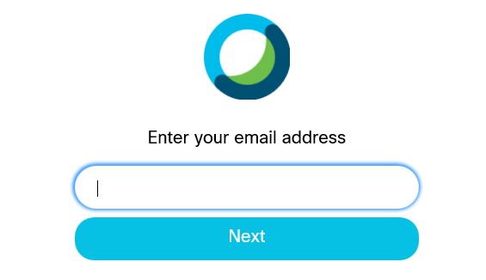
LOGIN:
Username: educationchair@wamss.org
Password: Wamss2019!
- Scheduling: Once logged in, click the “meetings” button on the left hand side, then, click “Schedule a Meeting”. Once here, you’ll be able to enter all the details of your meeting and send out the invite emails.
  - Scheduling a Meeting sending invites continued
After you select the Schedule button, the Schedule a Meeting screen will open for you to fill in the meeting information. Meeting topic; Meeting password is auto-populated; adjust the date/time by clicking on the date time use caution for the time zones; option to select a recurrence for the meeting; add in Attendees box email addresses with a comma or semicolon. When you add each attendee they will show below the Attendee box. This will send the attendees a meeting invite to add to their calendar. Show advanced options allows you to change your audio connection type, entry and exit tone, Agenda info can be added in this field. Scheduling Options allows for the alternate host, this is important to select “Let anyone with a host account on this site or anyone joining from a Cisco WebEx cloud-registered video device in this organization host my meeting” this will allow for others to start your meeting if you are not able to join on time. Automatic recording can be selected to start when the meeting starts (If you do select to record, please disclose to the members that the meeting is in active recording mode). This might be a good tool for the secretary or anyone that is taking minutes for the meeting. Look at the next section under Recording to see more on the recordings. Exclude password is also an option if you don’t want to include in the email invitation. Make sure to select the Schedule button to finish your meeting invite. You can also Save as template.
  - Your meeting invite will appear on your screen after you select the Schedule button. This is where you can copy, edit, cancel, and add to your calendar as well as start your meeting. The meeting information includes the link, meeting number, password, host key, and Agenda. More ways to join is also included by video system and by phone.
    - If you did not send out individual emails in the invite and want to send the meeting information in a group email or include on the WAMSS website or insert into another calendar invite, copy the meeting link, meeting number, password, video system and phone number with access code to share in one of the options above.

Recordings: Once the meeting is over you can find the recordings on the main tool bar on the left side of your screen. Click on the meeting recording you want to hear. The right side of the screen has a button with two profiles on it, click on this button to see the Participants Name and when they joined and left. The recording will include voice and visual that is shared during the meeting. Click the play icon to listen. To close the recording close the screen by selecting the x on your screen tab on the top of your screen. This will bring you back to the recorded meetings page. Again, on the recordings it will share the name of the meeting, date, duration, size, and format. You can also download the recording, share it, edit, or delete.

*Please check box below- so others in organization can host the meeting. 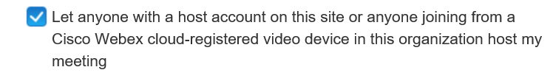
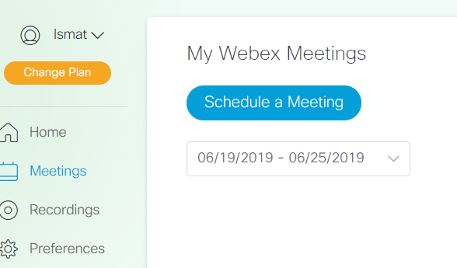
2. Starting a Meeting: Once logged in, from the home page, click the “Upcoming meetings” button, locate your meeting and click “Start.”
- The audio and video connection dialog box will open for you to confirm your systems. Click “Connect Audio and Video” Button to join the meeting.
3. To share your screen/content, Click the “Share Content” button:  and choose what you’d like to share with the group from the options listed. You should be able to share your screen or individual programs, for example excel, for everyone to see.
- If sharing a webinar, the best option would be to choose the specific program the webinar is playing on.
- Let everyone know to please mute to decrease background noise.
4. How to end the meeting: click File and select “End Meeting” or click  red X Circle button on screen, this will end your meeting session.

A note for hosts sites: Please ensure your conference room is equipped to handle video conferencing. Things to think about:
- Internet connection, with ability for people outside of your organization to get online. Or have a computer in the room to be used by our group. Test with your IT if you’re unsure before the meeting.
- Camera to see group in the room
- Speakers in room

For more detailed information and troubleshooting, please see the WebEx Help Center Website.
*Information outlined above is taken directly from the WebEx Webiste.
*Our current plan is for up to 100 participants.

