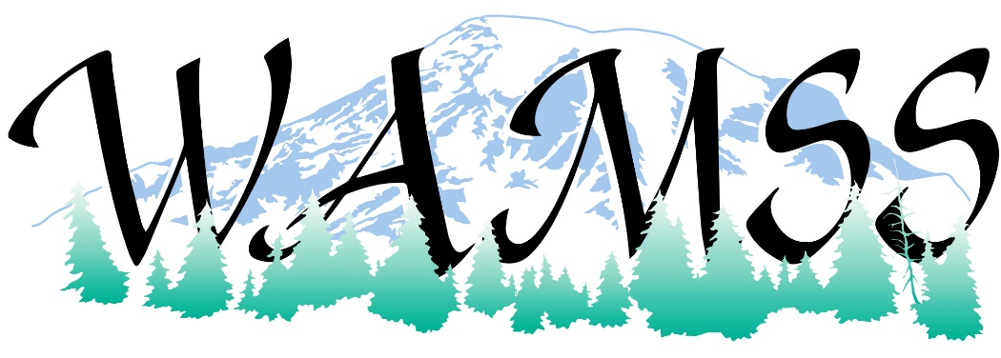
March 2020
As you know our group is on the frontlines of the healthcare industry, considered the “Gatekeepers of Patient Safety”. This is a challenging time for many due to the COVID-19 coronavirus. WAMSS has decided to transition our conference to virtual attendance only.
Washington Association Medical Staff Services (WAMSS) is excited to share sponsorship opportunities for our 41st Annual Education Virtual Conference on April 21-24, 2020. As in previous years, our vendors include credentialing software products, medical staff services products, professional development services and retail products. We know our conference attendees will benefit from your participation.
This is an excellent event for you to reach the members of WAMSS and all conference attendees! Our vision instead of a vendor table, is an electronic version of your materials for us to share with all conference attendees. WAMSS website will also advertise your company website link and logo. Gold and Silver Sponsors will include valuable time introducing their company prior to their sponsored session(s).
The benefits to our sponsors and exhibitors are outlined on the enclosed information pages. We offer a number of levels of sponsorships and, if needed, would work with you on negotiating a custom level of sponsorship. Your support of the profession of medical staff services and the Washington Association of Medical Staff Services is greatly appreciated at any level.
If you are interested in being a sponsor for the 2020 WAMSS Annual Education Conference, please contact us as soon as possible. The earlier you are signed up with WAMSS as a sponsor the sooner your benefits will start!
Thank you for checking your calendar for availability the week of April 21-24, 2020 to participate in our upcoming conference.
Sincerely,
WAMSS Conference Planning- Sponsorships
Sally Rowland  wamssconferencechair@gmail.com | Shannon Rochon  president@wamss.org

Contact WAMSS at Mailing Address: PO Box 218, Snoqualmie, WA 98065 or email us or visit us on our webpage: https://www.wamss.org/annual-conference/
Become a Conference Sponsor!
Increase your brand recognition and visibility at the Washington Association of Medical Staff Services (WAMSS) Conference.
Sponsor and Exhibitor Levels:
 | Gold  Sponsor  $1000 | Silver  Sponsor  $800 | Bronze  Sponsor  $300 | Exhibitor  $150
Complimentary registrations to conference  (CEU’s included) | 2 | 1 | 1
Pre-conference electronic attendee list emailed pre-conference (with allowed email addresses) | X | X | X
Distribution of company-specific information to attendees | X | X | X | X
Company listing in conference program | X | X | X | X
Color logo in attendee conference brochure | X | X | X
Color logo on WAMSS website with link to webpage | X  (9 months) | X  (6 months) | X  (2 months)
Introduction of your company during sponsored session(s) (day to present based on sponsorship level). | X | X

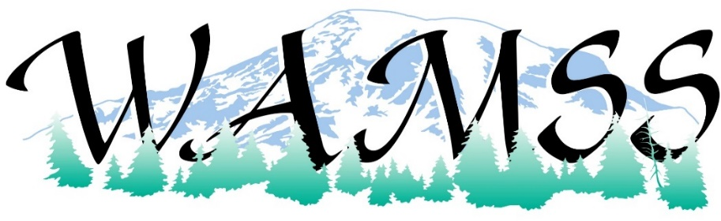
SPONSORSHIP OPPORTUNITY SELECTION
Gold - $1,000 Silver - $800 Bronze - $300 Exhibitor - $150
ORGANIZATION INFORMATION
Organization Name (as you would like it to appear in material)

Contact/Name/Title: Address:
City, State, Zip: Phone/Email: Organization Web Address:
SPONSORSHIP COMMITMENT AGREEMENT AND BILLING INFORMATION
I agree to my organization’s participation as a sponsor for WAMSS 2020 Annual Education Conference, April 21-24, 2020.

Print Name, Title, Organization

X Signature
Please submit your Sponsorship Check to (made payable to WAMSS):
PO Box 218, Snoqualmie, WA 98065 or email us or visit us on our webpage:
https://www.wamss.org/annual-conference/annual-conference-2020-april-21-24-2020/
Online Credit Card payments are also an option. Please contact us for an invoice.
email April.Logan@MolinaHealthcare.Com
THANK YOU FOR YOUR SUPPORT OF WAMSS!

