Northern Quest Hotel Reservations

Click the link below:
https://be.synxis.com/?_ga=2.210339286.2105578407.1588286066-1010515006.1522095536&adult=1&arrive=2021-04-16&chain=18073&child=0&currency=USD&depart=2021-04-26&group=20581&hotel=65230&level=hotel&locale=en-US&rooms=1&source=BookingWidget&template=initialConfig
Verify number of guests and check-in/check-out dates. Once it is correct, click SEARCH
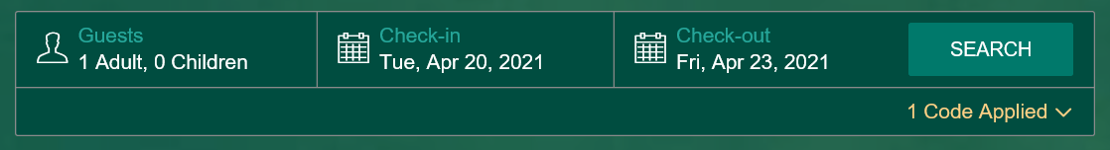
Your room selections will then come up. Choose which room you would like and click BOOK NOW
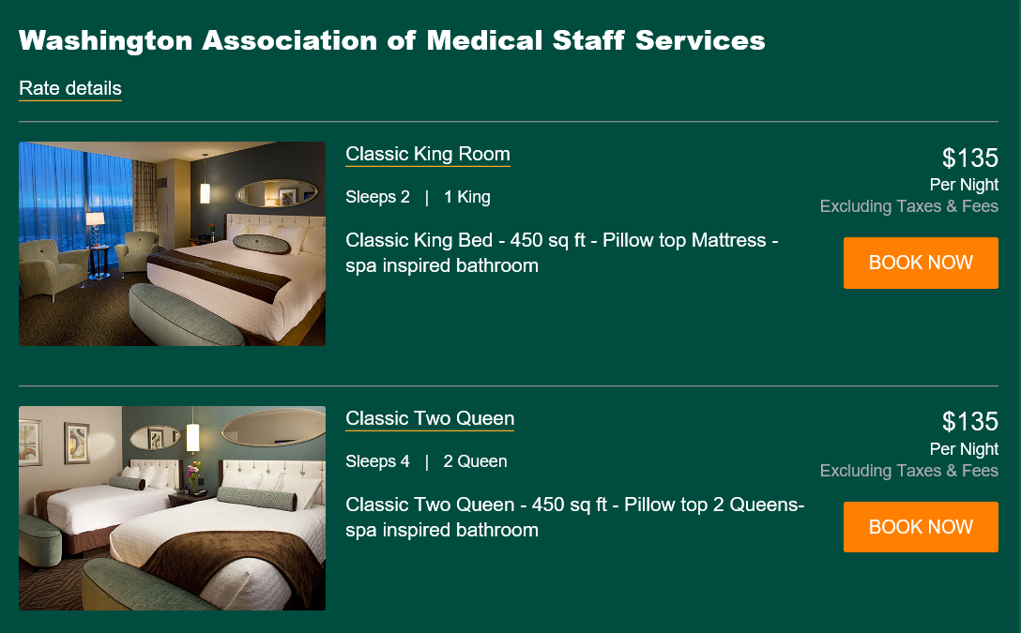
The next screen is the Add-Ons screen. There are several items that can be added on such as wine, flowers, or gift cards. These can be added by clicking show detail and add to my stay. After adding items or if you do not want to add items click CONTINUE TO BOOK.
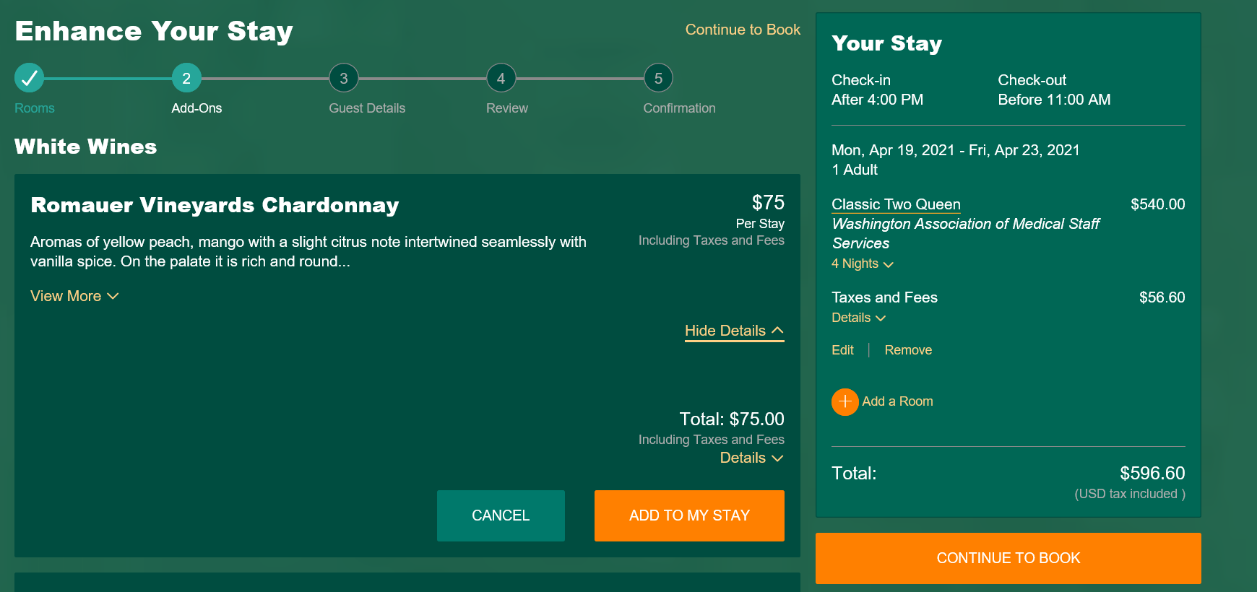
Next you will enter your contact and payment information. Click CONTINUE when done.
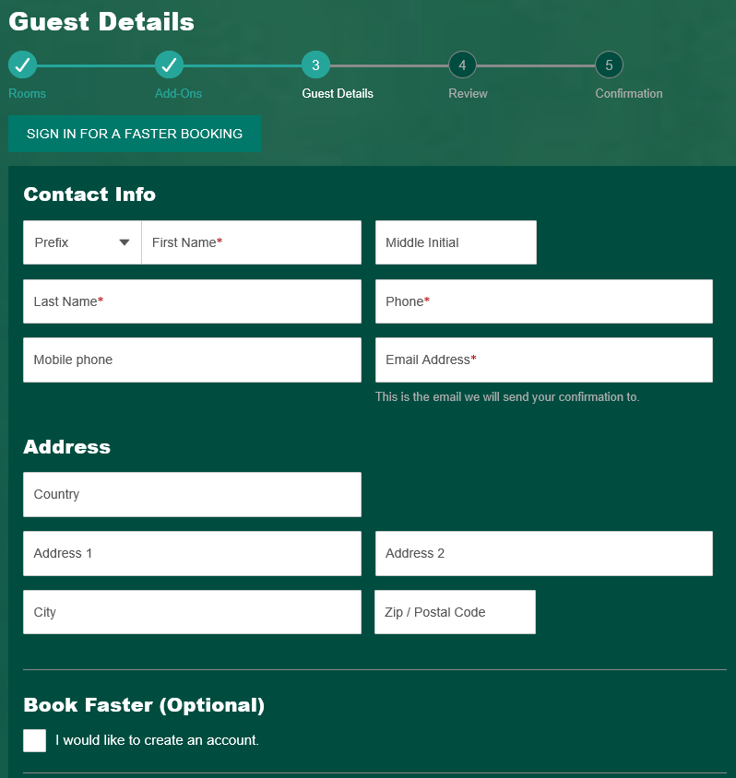
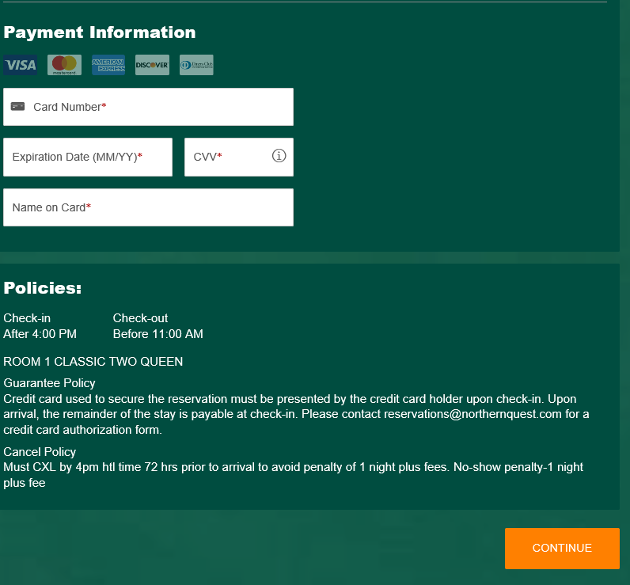

At the next screen you will review your booking details. Make sure everything is correct and answer the Acknowledgement questions at the bottom before clicking COMPLETE BOOKING.
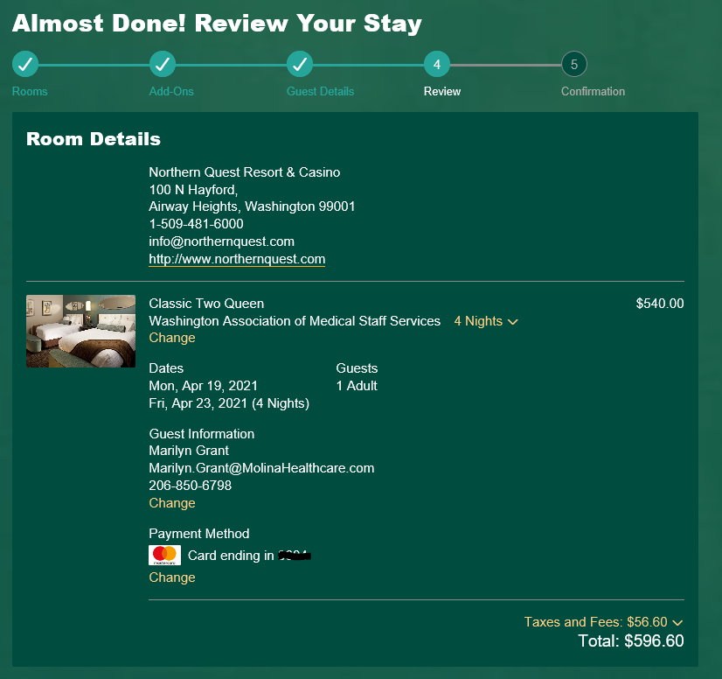
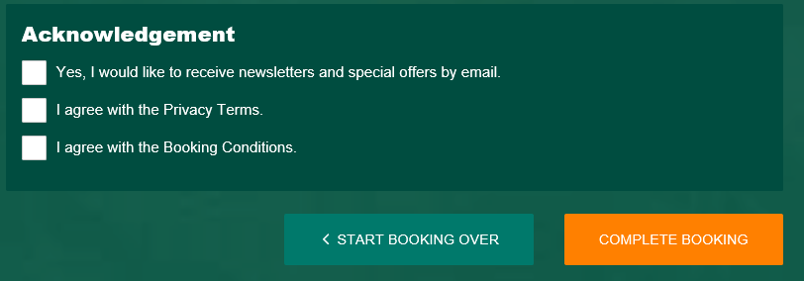
The final screen will be your confirmation information. Make sure you also receive a confirmation email.
