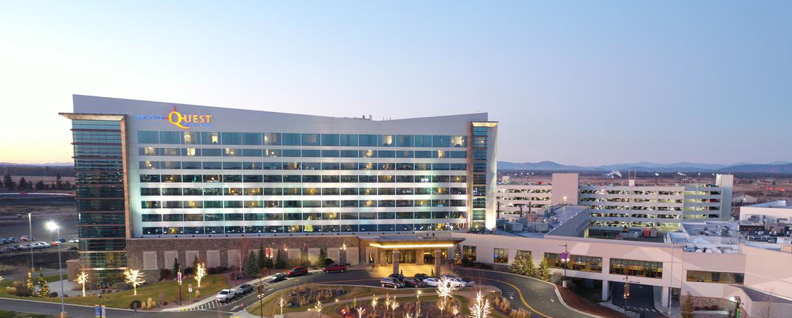

Hello Sponsors and Vendors!

If you are considering supporting the April 20-23, 2021 WAMSS Conference at Northern Quest, we encourage you to make your reservation now. This will secure your preferred lodging option. You can cancel your reservation up to 72-hours prior to arrival to avoid any penalty of 1-night plus fees. Please note that we have conference special pricing 3-days prior and 3-days post conference. I hope that you are able to take advantage of these great prices and enjoy the Resort with your family, friends or by yourself.

Attached please find instruction guides how to make reservations for both the Hotel and the RV Resorts. You will need a credit card to hold the reservation.

Reservations for Northern Quest Resort & Casino Hotel can be made anytime online. Currently the Resort reservation staff are not able to make reservations and we ask that you please register online. Once the Resort opens again, if you need support, please call the reservations line at 877-871-6772 and requesting the rate for Washington Association of Medical Staff Services or the booking ID which is 20581.
Here is the updated link for hotel reservations: https://be.synxis.com/?_ga=2.210339286.2105578407.1588286066-1010515006.1522095536&adult=1&arrive=2021-04-16&chain=18073&child=0&currency=USD&depart=2021-04-26&group=20581&hotel=65230&level=hotel&locale=en-US&rooms=1&source=BookingWidget&template=initialConfig

Reservations for Northern Quest RV Resort can be made anytime online. Currently the Resort reservation staff are not able to make reservations and we ask that you please register online. Once the Resort opens again, if you need support, please call the reservations line at 833-702-2082 and requesting the rate for Washington Association of Medical Staff Services or the booking ID which is 20581.
Here is the link for the RV resort reservations. https://be.synxis.com/?_ga=2.87988632.1434391158.1588263343-1632803826.1588263343&adult=1&arrive=2021-04-16&chain=24582&child=0&currency=USD&depart=2021-04-26&group=20581&hotel=7079&level=hotel&locale=en-US&rooms=1&source=BookingWidget
Any guests that are flying are welcome to set up complimentary airport shuttles by contacting our transportation team at transportation@northernquest.com or calling 509-481-6810 and be sure to have flight information and cell phone numbers.

We look forward to seeing you at Northern Quest!

