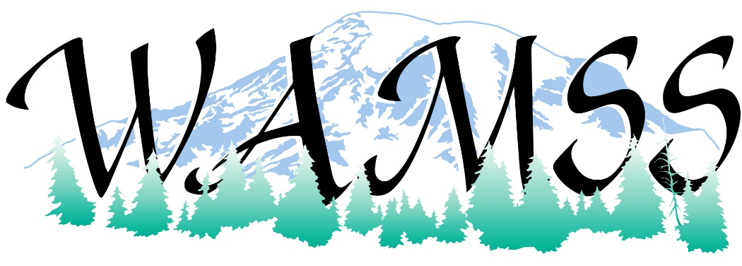
Washington Association Medical Staff Services (WAMSS) is excited to share with you vendor sponsorship opportunities at our 42nd Annual Education Conference “Thriving Through Change” on April 21-23, 2021, at the Northern Quest Resort, just a few minutes from Spokane in Airway Heights, Washington. www.northernquest.com
Since many of our members do not have the opportunity to attend the National Association Medical Staff Services Conference where vendors regularly have displays, this is an excellent event for you to reach the members of WAMSS. As in previous years, our vendors include credentialing software products, medical staff services products, professional development services, and retail products. We know our conference attendees will benefit from your participation.
The benefits to our sponsors and exhibitors are outlined on the enclosed information pages. We offer several levels of sponsorships and, if needed, would work with you on negotiating a custom level of sponsorship. Your support of the profession of medical staff services and the Washington Association of Medical Staff Services is greatly appreciated at any level.
If you are interested in being a vendor and/or sponsor for the 2021 WAMSS Annual Education Conference, please contact us as soon as possible. The earlier you are signed up with WAMSS as a sponsor, the sooner your benefits will start!
Thank you for checking your calendar for availability for April 21-23, 2021, to participate at our upcoming conference.
Sincerely,
WAMSS Conference Planning Chair
Shannon Rochon
wamssconferencechair@gmail.com

Contact WAMSS at Mailing Address: PO Box 218, Snoqualmie, WA 98065 or email us or visit us on our webpage: https://www.wamss.org/annual-conference/
Become a Conference Sponsor! Increase your brand recognition and visibility at the Washington Association of Medical Staff Services (WAMSS) Conference.
Sponsor and Exhibitor Levels:
 |  | Gold  Sponsor  $2000 | Silver  Sponsor  $1000 | Bronze  Sponsor  $750 | Exhibitor  $300 | Materials/SWAG for Attendee Bag  $150
Conference electronic attendee list emailed  (with allowed email addresses) |  | X | X | X
Company logo and listing in conference program |  | X | X | X | X
Complimentary exhibit space  (6 Foot table in Exhibit Hall) |  | X  (priority selection) | X | X | X
Color logo on WAMSS website |  | X  (6 months) | X  (3 months) | X  (2 months) | X  (1 month) | X  (1 month)
Introduction of your company during event session, and 5 minutes to address attendees  (day to present based on sponsorship level). |  | X
Contact us for pricing and further details:
Event Options | Sponsorship Details
Opening Reception | Ice breaker/welcome reception  Recognition signage for hosting reception
Hosted Breakfast(s) | Recognition signage for hosting breakfast(s)
Hosted Break(s) | Recognition signage for hosting break(s)
Hosted Lunch(s) | Recognition signage for hosting lunch(s)
Hosted Social Event | Recognition signage for hosting Social Event
Any of the above sponsorships include: | Company logo and listing in conference program, Color logo on WAMSS website for 6 months, attendee list, Large recognition sign at event

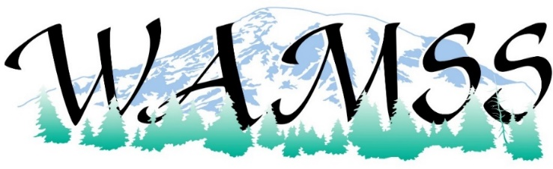

SPONSORSHIP OPPORTUNITY
Please select desired option(s) below:
 | Gold Sponsorship | $2000
 | Silver Sponsorship | $1000
 | Bronze Sponsorship | $750
 | Exhibitor | $300.00
 | Materials/SWAG for Attendee Bag | $150.00
 | Door Prize Donation (Gift Card, Gift Basket, etc.) | Item
 | Event Option: _________________________ | TBD
ORGANIZATION INFORMATION
Organization Name (as you would like it to appear in printed material)
Contact/Name/Title: Address:
City, State, Zip: Phone/Email: Organization Web Address:
SPONSORSHIP COMMITMENT AGREEMENT AND BILLING INFORMATION
I agree with my organization’s participation as a sponsor for WAMSS 2021 Annual Education Conference, April 21-23, 2021 at Northern Quest Resort, just a few minutes from Spokane in Airway Heights, Washington. www.northernquest.com

Print Name, Title, Organization
X Signature
Please submit your Sponsorship Check to (made payable to WAMSS):
PO Box 218, Snoqualmie, WA 98065 or email us or visit us on our webpage:
https://www.wamss.org/annual-conference/8063-2/
Online Credit Card payments are also an option. Please contact us for an invoice.
email wamssconferencechair@gmail.com
THANK YOU FOR YOUR SUPPORT OF WAMSS!!!!

