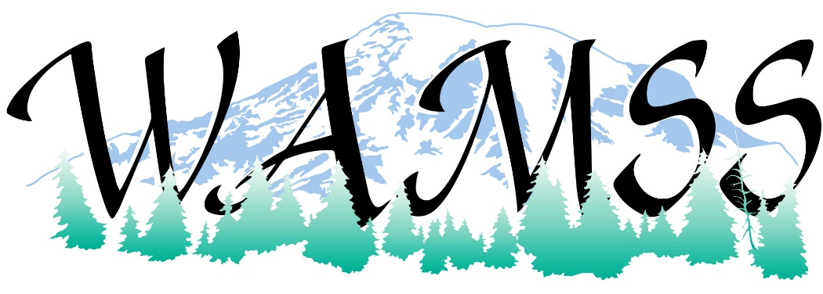
Washington Association Medical Staff Services (WAMSS) is excited to share with you vendor sponsorship opportunities at our 42nd Annual Education Virtual Conference “Thriving Through Change” on April 21-23, 2021.
Since many of our members do not have the opportunity to attend the National Association Medical Staff Services Conference where vendors regularly have displays, this is an excellent event for you to reach the members of WAMSS. As in previous years, our vendors include credentialing software products, medical staff services products, professional development services, and retail products. We know our conference attendees will benefit from your participation.
The benefits to our sponsors and exhibitors are outlined on the enclosed information pages. We offer several levels of sponsorships and, if needed, would work with you on negotiating a custom level of sponsorship. Your support of the profession of medical staff services and the Washington Association of Medical Staff Services is greatly appreciated at any level.
If you are interested in being a vendor and/or sponsor for the 2021 WAMSS Annual Education Conference, please contact us as soon as possible. The earlier you are signed up with WAMSS as a sponsor, the sooner your benefits will start!
Thank you for checking your calendar for availability for April 21-23, 2021, to participate at our upcoming conference.
Sincerely,
WAMSS Conference Planning Chair
Shannon Rochon
wamssconferencechair@gmail.com

Contact WAMSS at Mailing Address: PO Box 218, Snoqualmie, WA 98065 or email us or visit us on our webpage: https://www.wamss.org/annual-conference/
Become a Conference Sponsor! Increase your brand recognition and visibility at the Washington Association of Medical Staff Services (WAMSS) Conference.
Sponsor and Exhibitor Levels: | Gold  Sponsor  $2000 | Silver  Sponsor  $1000 | Bronze  Sponsor  $750 | Exhibitor  $300
Conference electronic attendee list emailed  (with allowed email addresses) | X | X | X
Company logo and digital materials on WAMSS website | X | X | X | X
Color logo, link to website and digital materials on WAMSS website | X  (6 months) | X  (3 months) | X  (2 months) | X  (1 month)
Introduction of your company during event session, and 5 minutes to address attendees  (day to present based on sponsorship level). | X
Please select desired option(s) below:
 | Gold Sponsorship | $2000
 | Silver Sponsorship | $1000
 | Bronze Sponsorship | $750
 | Exhibitor | $300
 | Door Prize Donation (Gift Card, Gift Basket, etc.) | Item
ORGANIZATION INFORMATION
Organization Name (as you would like it displayed)
Contact/Name/Title: Address:
City, State, Zip: Phone/Email: Organization Web Address:
SPONSORSHIP COMMITMENT AGREEMENT AND BILLING INFORMATION
I agree with my organization’s participation as a sponsor for WAMSS 2021 Virtual Conference, April 21-23, 2021

Print Name, Title, Organization
X Signature
Please submit your Sponsorship Check to (made payable to WAMSS):
PO Box 218, Snoqualmie, WA 98065 email us or visit us on our webpage:
https://www.wamss.org/annual-conference/8063-2/
Online Credit Card payments are also an option. Please contact us for an invoice.
email wamssconferencechair@gmail.com

