Northern Quest RV Resort Reservations

Click the link below:
https://be.synxis.com/?_ga=2.265610063.1982671681.1628708981-1127980639.1619188742&adult=1&arrive=2021-08-11&chain=24582&child=0&currency=USD&depart=2021-08-12&hotel=7079&level=hotel&locale=en-US&rooms=1&source=BookingWidget
Verify number of guests and check-in/check-out dates. Once it is correct, click SEARCH
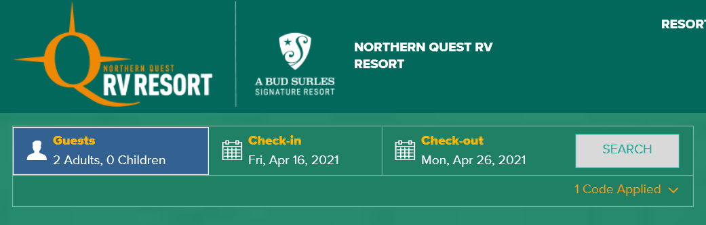
Your site selections will then come up. Choose which site you would like and click BOOK NOW
Cottages:
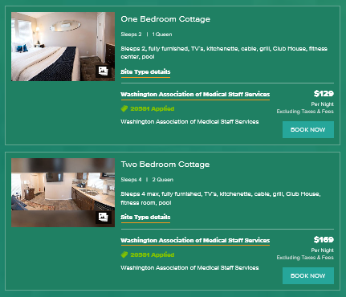

RV Sites:
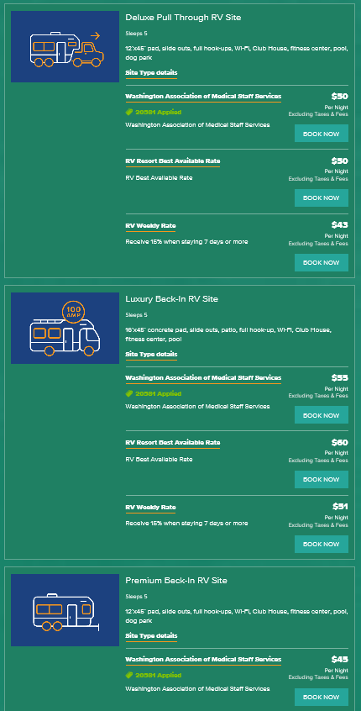
Next you will enter your contact and payment information. Click CONTINUE when done.
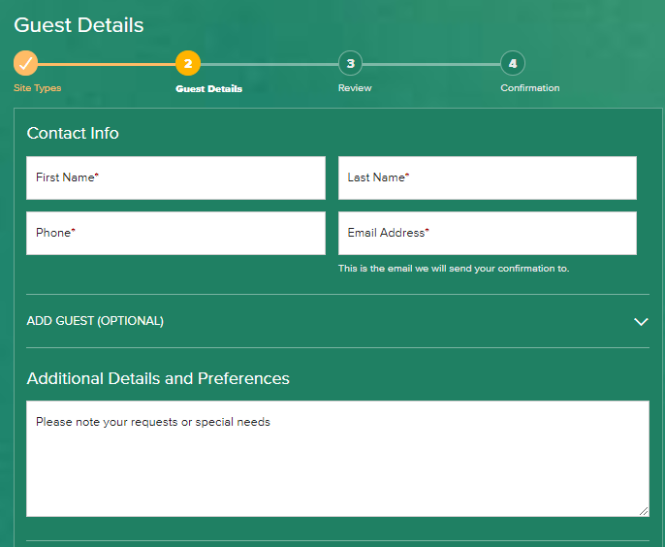
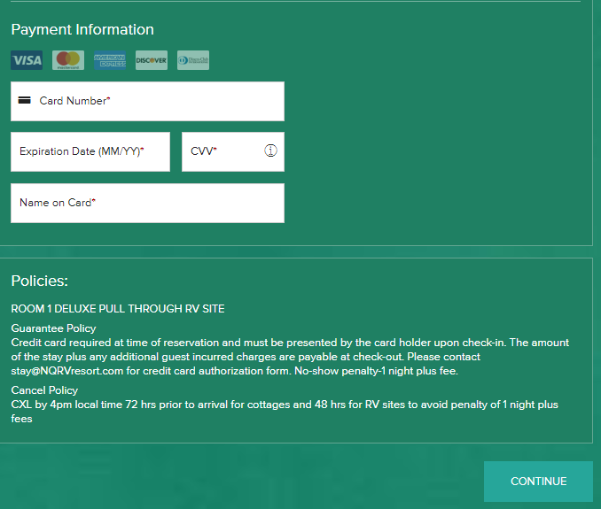

At the next screen you will review your booking details. Make sure everything is correct and answer the Acknowledgement questions at the bottom before clicking COMPLETE BOOKING.
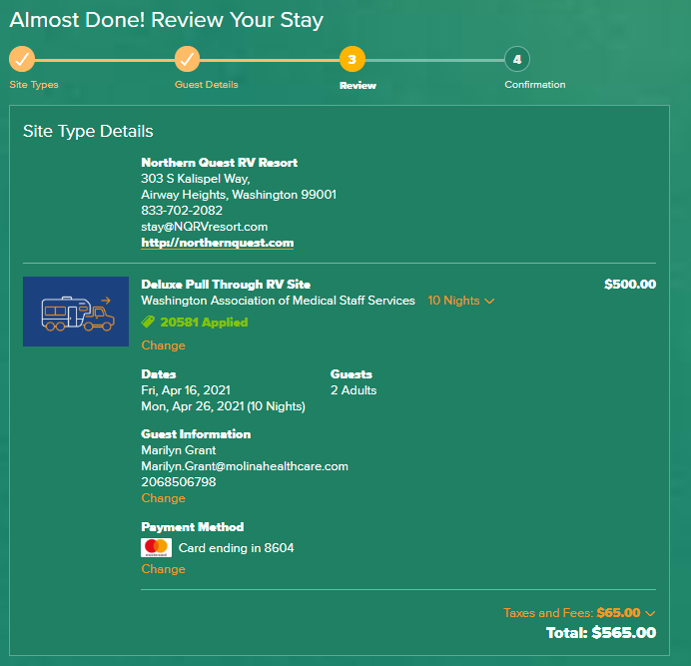
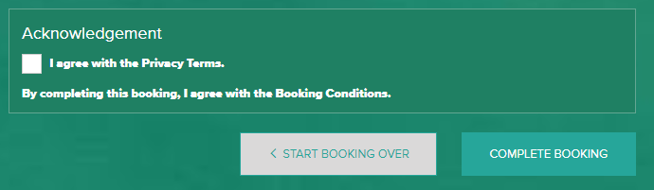
The final screen will be your confirmation information. Make sure you also receive a confirmation email.
