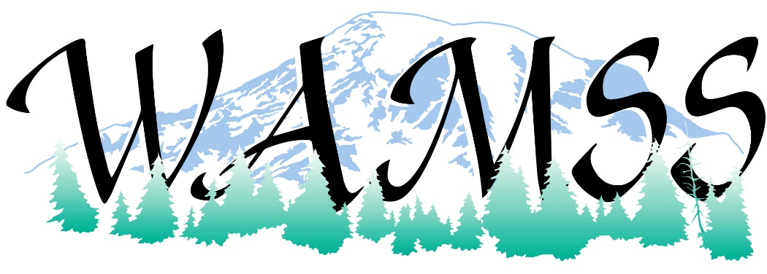
Washington Association Medical Staff Services (WAMSS) is excited to share with you vendor sponsorship opportunities at our 43rd Annual Education Conference “Innovate, Integrate, Motivate” April 27-29, 2022, at the Northern Quest Resort, just a few minutes from Spokane in Airway Heights, Washington. www.northernquest.com
Since many of our members do not have the opportunity to attend the National Association Medical Staff Services Conference where vendors regularly have displays, this is an excellent event for you to reach the members of WAMSS. As in previous years, our vendors include credentialing software products, medical staff services products, professional development services, and retail products. We know our conference attendees will benefit from your participation.
The benefits to our sponsors and exhibitors are outlined on the enclosed information pages. We offer several levels of sponsorships and, if needed, will work with you on negotiating a custom level of sponsorship such as the Attendee Bag. Your support of the profession of medical staff services and the Washington Association of Medical Staff Services is greatly appreciated at any level.
If you are interested in being a vendor and/or sponsor for the 2022 WAMSS Annual Education Conference, please contact us as soon as possible. There is limited vendor space available. The earlier you are signed up with WAMSS to secure your space, the sooner your benefits will start!
Thank you for checking your calendar for availability for April 27-29, 2022, to participate in our upcoming conference.
Sincerely,
WAMSS Conference Planning Chair
Lynn Everts

Contact WAMSS at Mailing Address: 601 S. Pioneer Way Ste F #399, Moses Lake, WA 98837
email WAMSS Conference Chair wamssconferencechair@gmail.com
or visit us on our webpage: https://www.wamss.org/annual-conference/
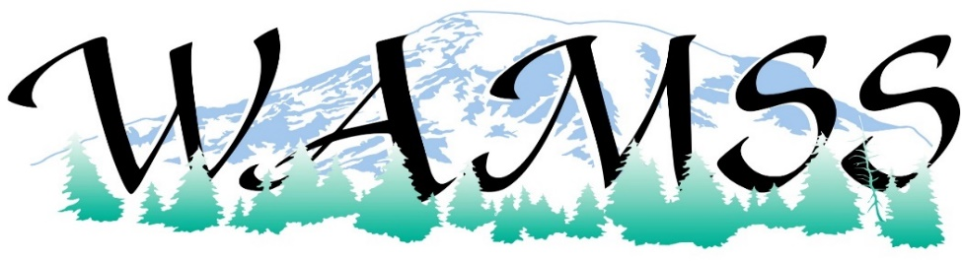
“Innovate, Integrate, Motivate” April 27-29, 2022
Become a Conference Sponsor! Increase your brand recognition and visibility at the Washington Association of Medical Staff Services (WAMSS) Conference.
Sponsor and Exhibitor Levels:
 |  | Gold  Sponsor  $2000 | Silver  Sponsor  $1000 | Bronze  Sponsor  $750 | Exhibitor  $300 | Materials/SWAG for Attendee Bag  $150
Conference electronic attendee list emailed  (with allowed email addresses) |  | X | X | X
Company logo and listing in conference program |  | X | X | X | X
Complimentary exhibit space  (6 Foot table in Exhibit Hall) |  | X  (priority selection) | X | X | X
Color logo on WAMSS website |  | X  (6 months) | X  (3 months) | X  (2 months) | X  (1 month) | X  (1 month)
Introduction of your company during event session, and 5 minutes to address attendees  (day to present based on sponsorship level). |  | X
Contact us for pricing and further details:
Event Options | Sponsorship Details
Tuesday Opening Reception | Ice breaker/welcome reception  Recognition signage for hosting reception
Wednesday Vendor Hosted Lunch | All vendors wanting to participate will share final cost of lunch. Includes presentation time for each vendor and engagement with attendees.
Wednesday hosted Social Event | Recognition signage for hosting Social Event
Hosted Breakfast(s), Break(s) or Lunch(s) | Recognition signage for hosting event
Any of the above sponsorships include: | Company logo and listing in conference program, Color logo on WAMSS website for 6 months, attendee list, Large recognition sign at event

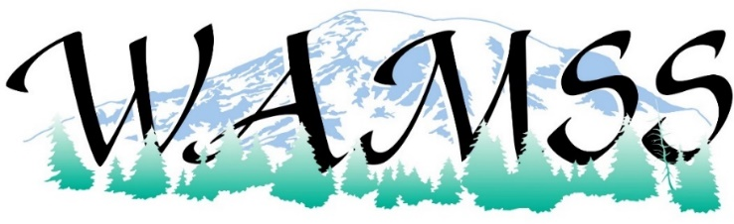
“Innovate, Integrate, Motivate” April 27-29, 2022

SPONSORSHIP OPPORTUNITY Please select desired option(s) below:
 | Attendee Bag with WAMSS and Your Company Logos | TBD
 | Gold Sponsorship | $2000
 | Silver Sponsorship | $1000
 | Bronze Sponsorship | $750
 | Exhibitor | $300.00
 | Materials/SWAG for Attendee Bag | $150.00
 | Door Prize Donation (Gift Card, Gift Basket, etc.) | Item
 | Event Option: _________________________ | TBD

ORGANIZATION INFORMATION
Organization Name (as you would like it to appear in printed material)
Contact/Name/Title: Address:
City, State, Zip: Phone/Email: Organization Web Address:
SPONSORSHIP COMMITMENT AGREEMENT AND BILLING INFORMATION
I agree with my organization’s participation as a sponsor for WAMSS 2022 Annual Education Conference, April 27-29, 2022 at Northern Quest Resort, just a few minutes from Spokane in Airway Heights, Washington. www.northernquest.com

Print Name, Title, Organization
X Signature
Please submit your Sponsorship Check to (made payable to WAMSS):
601 S. Pioneer Way Ste F #399, Moses Lake, WA 98837

Online Credit Card payments are also an option and will include a 3% credit card processing fee. Please contact us for an invoice.
email us wamssconferencechair@gmail.com
visit us on our webpage: https://www.wamss.org/annual-conference/
THANK YOU FOR YOUR SUPPORT OF WAMSS!!!!

